Person Class:

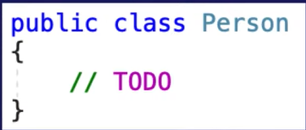

Logger Class:

Without Dependency Injection

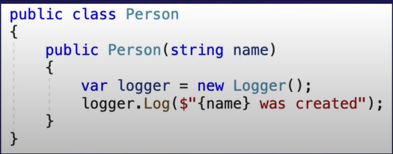

With Dependency Injection

Ways of doing dependency injections:

Constructor Injection:

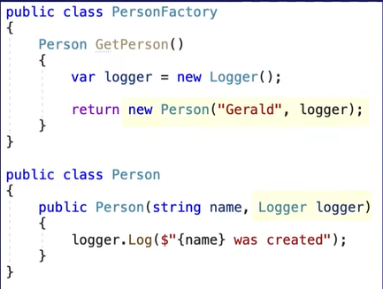

Method Injection:

Property:

**Example 2:**

**TextLogger**:

**DatabaseLogger**:

**Program for TextLogger Use:**

**Program for DatabaseLogger Use:**

**Now With DI:**

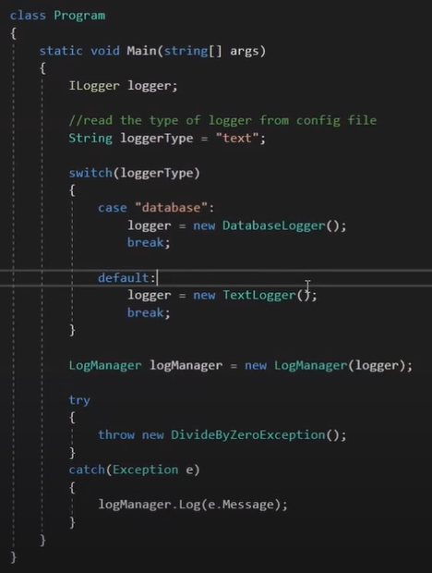

**Example 3:**

